Reward Card Testing

1. Test for readability

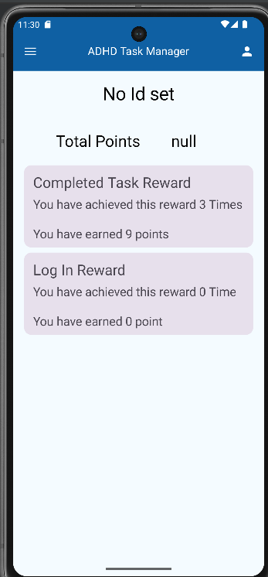

* The information is now presented in a more readable manner.

1. Numerical accuracy

* as per the above screenshot, the plural and singular context is taken into consideration when displaying the information.
* the numbers in the card reflects the values from the database. See image below. Each task completion is given 3 points.
  + for numbers < 2, the singular form of the noun is used.

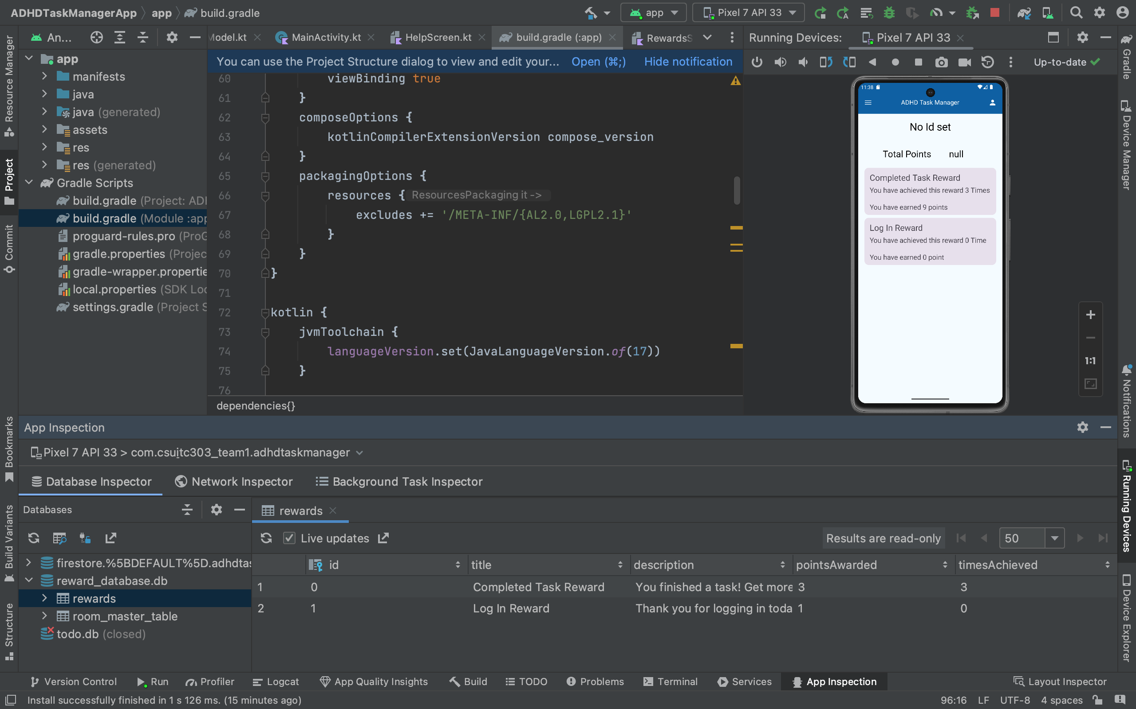

Help page testing

* Some of the resources, such as the demo video, requires good internet connection.
* No internet or poor internet connection throws an error as per the image below.

